**University of British Columbia**

**Economics 490 (Section 003)**

**Project Proposal**

Name: Saksham Sudershan Student ID: 31339427

According to an article by ScienceDaily on a paper by the Massachusetts Institute of Technology (2020), the rate of airline passenger mortality globally was one death per 7.9 million passenger boardings during the period 2008-2017, compared to one death per 2.7 million boardings during the period 1998-2007. Indeed, today, commercial air travel is safer than it has been at any point, as supported by Fig. 1 which shows a trend of reduced airplane accidents.

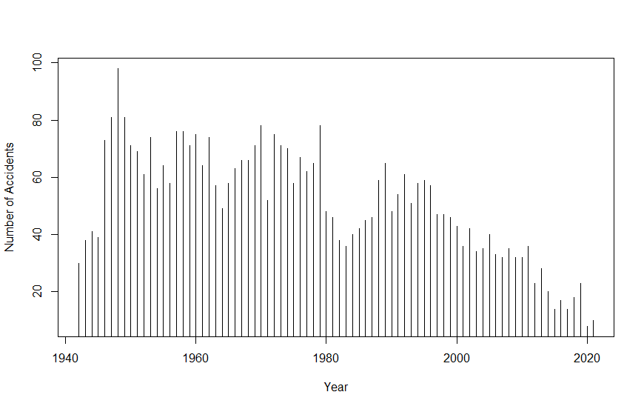

Fig. 1: Frequency of accidents per year. Source: Aviation Safety Network (2021)

The US is also considered to be amongst the regions which house the lowest-risk airlines, with a lower rate of one death per 33.1 million passengers, according to the ScienceDaily article.

In April 2021, The Wall Street Journal published an article titled “The Airline Safety Revolution” (Pasztor, 2021), crediting the policy of the Federal Aviation Administration’s Aviation Safety Action Program introduced in 1997 towards a ‘remarkable’ reduction in the rate of fatal accidents. This program encourages voluntary reporting of safety issues for enforcement-related incentives. While this enhances communication between carriers and the FAA, this program lowers the fines incurred by airlines.

Often, the FAA is criticized for the lack of stiffer fines (Joseph Gutheinz Jr, as cited by David Koenig, 2008), however in the case of an efficient stock market, the market forces discipline the firm, reducing the need for a regulatory body. This is the basis for the paper “The Effect of Aviation Disasters on the Air Transport Industry” (Chance & Ferris, 1987), which concludes that while the airlines involved in the crash suffer a loss, there is no reaction on the part of the stocks not related, thus not impacting the industry. This is contested by the paper “The Competitive Impact of Air Crashes: Stock Market Evidence” (Bosch, Eckard & Singal, 1998) which summarizes that while there is a mostly a switch to rival companies, there is also an impact on the industry as a whole.

Both of the papers argue that the free market has the ability to enforce safety, taking the place of the regulatory authority, that is the FAA in this case.

This paper intends to explore if in the aftermath of the ASAP policy, the free market tends to ‘fine’ the airlines involved in the crash more than before 1997. We can investigate crashes 15 years before 1997, and 15 years after 1997 in the US by major airlines that are included in the Dow Jones Transportation Average, as given below:

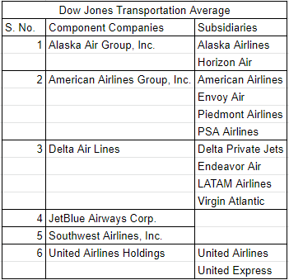

The stock returns analyzed would be from CRSP stock data, and the event dates would be as mentioned in news articles. By measuring the effect of each crash event on the returns of these airlines, we can compare the before-1997 figures to after-1997 figures to see if the free market has taken over the role of the FAA. To establish causality, it could also be of interest to compare these figures to a country which shows common trends of air failures in the same time period, but does not have a policy similar to the ASAP in the US. This would act as a placebo test.

The results of this paper would indicate that the free market takes into account the regulatory authority’s passiveness and still incentivizes firms to provide a safer product. With the reduction that we see in air disasters today, this could further suggest the need or the lack thereof of a regulatory body in areas where safety is of the utmost priority.

**References**

Aviation Safety Network. (2021, November 10). Retrieved from

https://aviation-safety.net/statistics/period/stats.php?cat=A1.

Bosch, J., Eckard, E. W., & Singal, V. (1998). The Competitive Impact of Air Crashes: Stock

Market Evidence. *The Journal of Law & Economics, 41*(2), 503-519.

Chance, D. M., & Ferris, S. P. (1987). The Effect of Aviation Disasters on the Air Transport

Industry: A Financial Market Perspective. *Journal of Transport Economics and Policy, 21*(2), 151-165.

Koenig, D. (2008, March 7). *Southwest faces record FAA penalty.* The Philadelphia Inquirer.

Retrieved from https://www.inquirer.com/philly/business/20080307_Southwest_faces_record_FAA_penalty.html.

Massachusetts Institute of Technology. (2020, January 24). Commercial air travel is safer than

ever: The rate of passenger fatalities has declined yet again in the last decade, accelerating a long-term trend. ScienceDaily. Retrieved November 9, 2021 from www.sciencedaily.com/releases/2020/01/200124124510.htm.

Pasztor, A. (2021, April 16). *The Airline Safety Revolution.* The Wall Street

Journal. Archived and retrieved from https://archive.md/rnTR0.